**Complex Systems HW 3.A**

Maike Holthuijzen and Alex Burnham

March 6, 2018

**Implementation of this Greenberg-Hastings cellular automata-based S.I.R. model:**

In our Greenberg-Hastings S.I.R. model, we implemented the functionality to change the rate of infection, the infection duration, the number of time steps the model runs for, and dimension of the toroidal matrix. In addition, we added options to allow for immigration, stochastic and deterministic initializations of the starting map, and two types of updating (synchronous and asynchronous). Susceptible individuals transition to infected based on the number of infected individuals within the susceptible individual’s Von Neumann neighborhood and the infection probability p. Infected individuals stay infected for “a” time steps and transition to recovered at g+1. If immigration_rate is specified, infected individuals randomly enter the population. In our implementation of immigration, we updated a random proportion of the cells equal to the immigration rate to infected status (a number between 1 and a) after other updates were completed. For instance, if the immigration rate is equal to 0.05, then 5% of all cells are assigned a random value between 1 and a. If the immigration rate is set to 0, no immigration takes place. A stochastic implementation of the model can be specified by setting initmap and random to 0. The model is deterministic if initmap is specified with a square matrix . In addition, synchronous and asynchronous versions of the model can be designated by setting method to “synchronous” or “asynchronous”. In the case of synchronous updating, all cells are changed simultaneously at the end of every time step based on their current values. In asynchronous updating, all cells are updated in a random order using their real-time values. Thus, we can make conclusions about SIR model behavior by observing the model results using varying combinations of argument values.

**1 - Initial Conditions 1 from figure 6.6 to produce top row of images from figure 6.7**

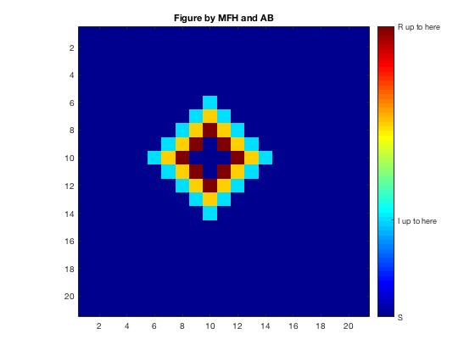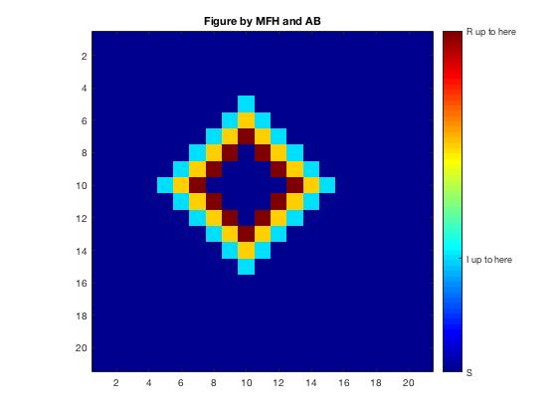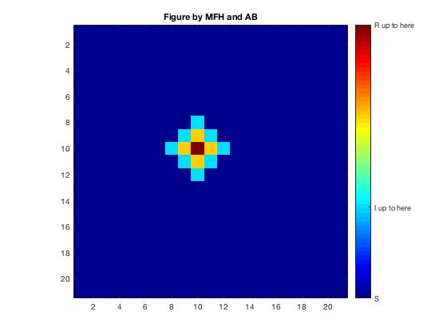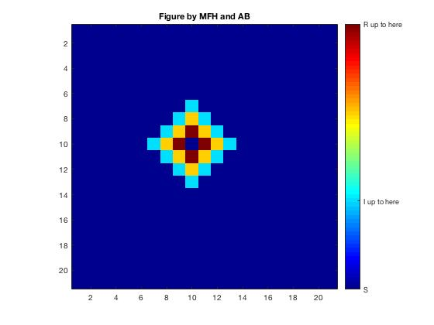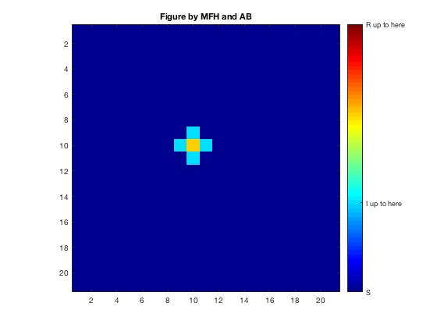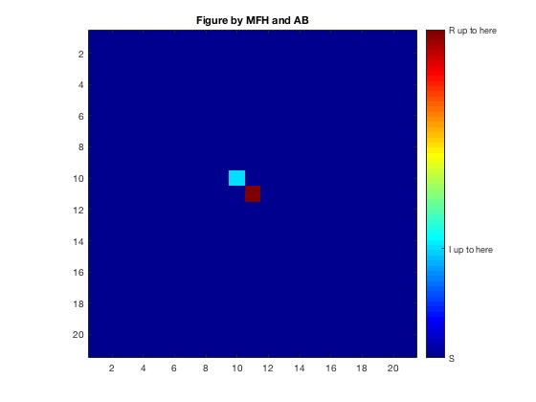The following figures show that the model works as intended (p=1, a=1, g=2, immigration_rate=0) in the first few time steps. This model releases a pulse of infected individuals radiating out from the predetermined cell values, eventually dying out.

**2 - Initial Conditions 2 from Figure 6.6 replicated the second row of images from figure 6.7**

The following figures show that the model works as it intended (p=1, a=1, g=2, immigration_rate=0 and synchronous updating) in the first few time steps. This model releases a pulse of infected individuals repeatedly radiating from the center of the predetermined cells.

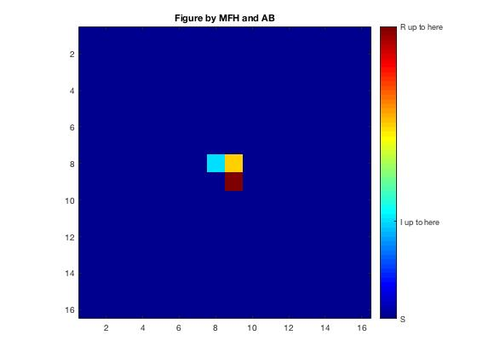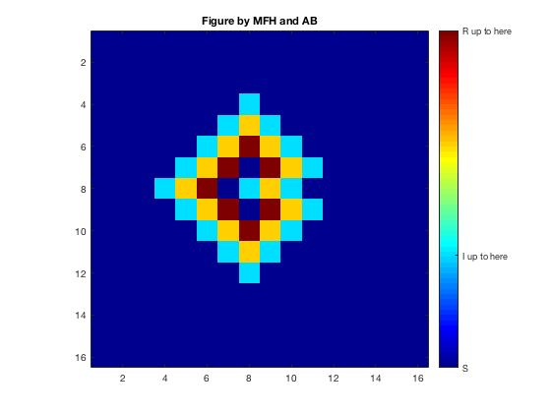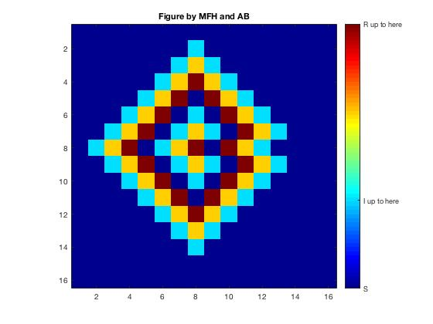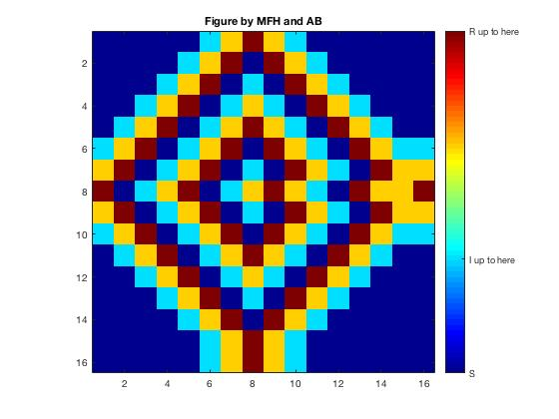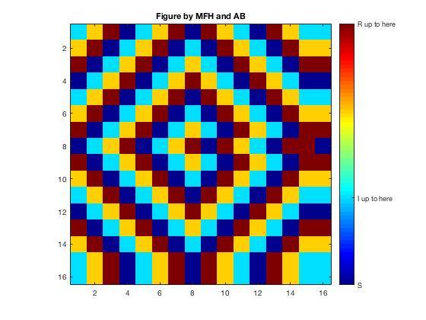

**3 - Initial Conditions 1 from figure 6.6 with asynchronous updating**

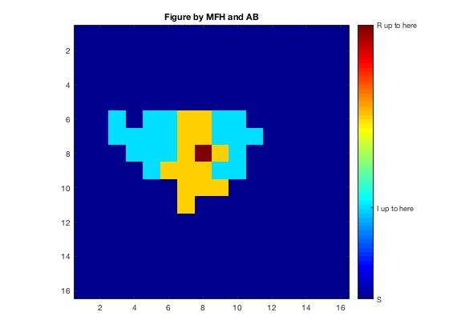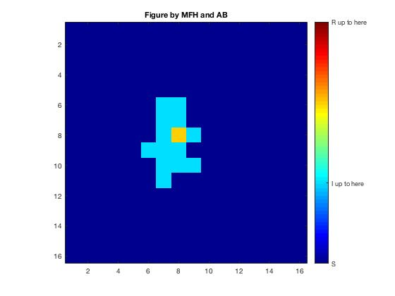The following images show that we can implement a model that is updated asynchronously by altering the known synchronous form shown in figure 1 (p=1, a=1, g=2, immigration_rate=0 and asynchronous updating). This model follows a similar pattern to synchronous counterpart, however, it does so with slight perturbations to the pattern. The asynchronous version has more of a stochastic attribute to it as values are updated cell by cell in random order, potentially changing the states of cells adjacent to cells that have yet to be updated.

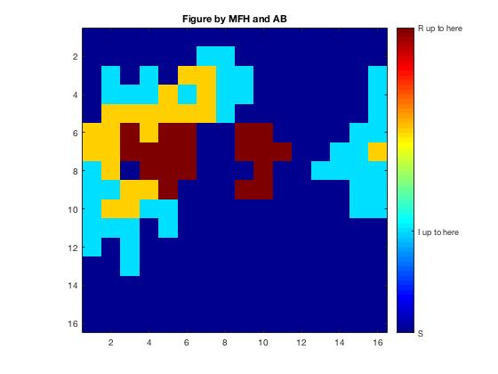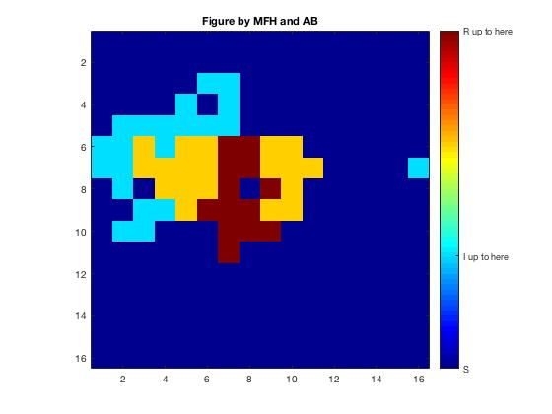

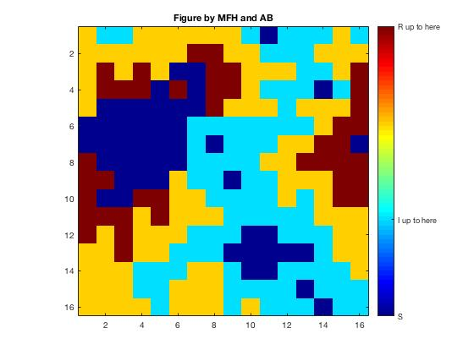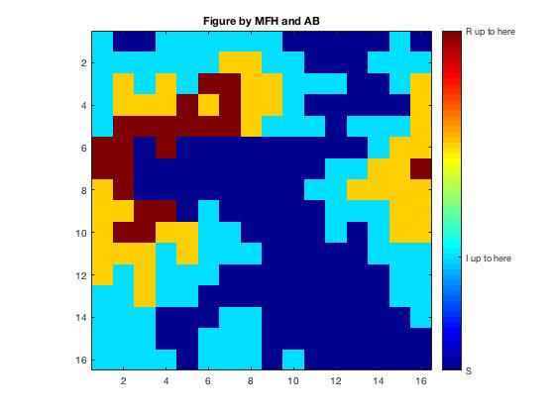

**4 - Initial Conditions 1 from figure 6.6 with synchronous updating and immigration**

The following images show that we can implement immigration with a synchronous system by altering a known synchronous form shown in figure 1 (p=1, a=1, g=2, immigration_rate = 0.5 and synchronous). In this system, the deterministic form is altered by changing 50% of the cells to infected status (a value between 1 and a) at random coordinates. This adds a different form of stochasticity, where at each synchronous time step, 50% of the cells become “new” infected individuals in the population.

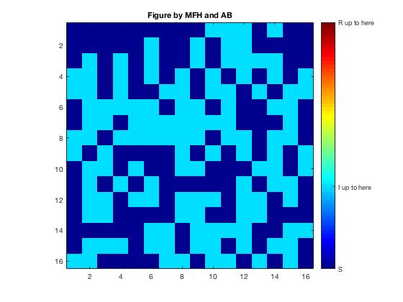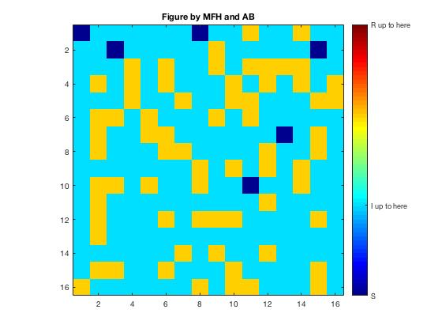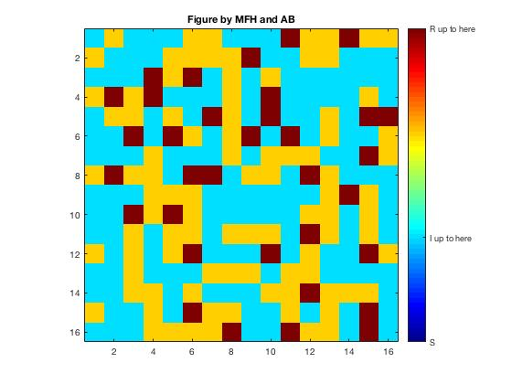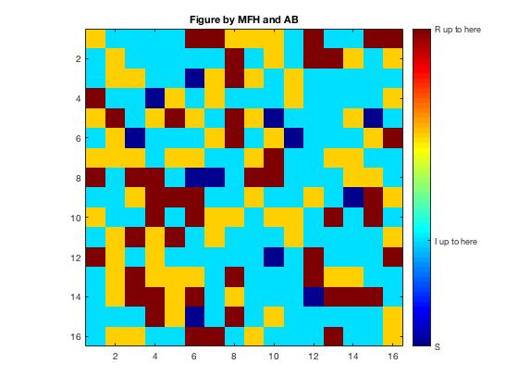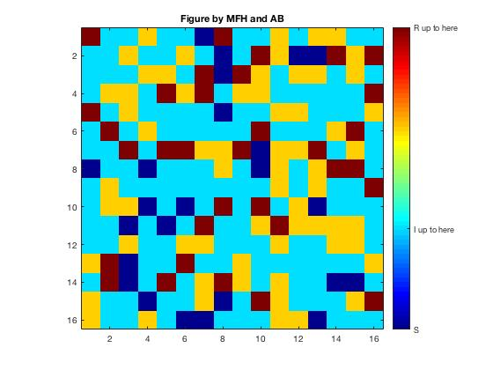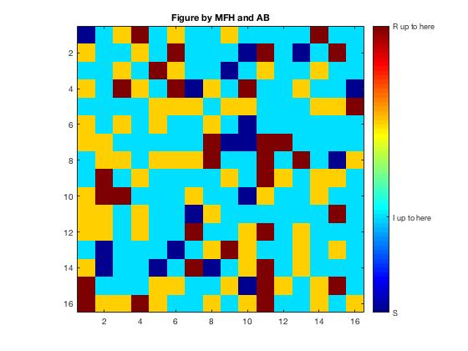

**5 - Stochastic model with synchronous updating and a probability of infection, “p”, of 0.2**

The following images show that we implemented the random map and it works with different values of “p” (p=0.2, a=1, g=2,I=0, immigration_rate=0 and synchronous). This model iteration differs from the previous one in that it does not begin deterministically. Instead, the map is created randomly with each cell randomly ranging from 0 to a+g It updates synchronously, but relative to p = 1, a lower value of p adds another layer of stochasticity to the model. This is important to implementation as in most disease systems, there is not a 100% chance of transmission on contact. In later stages of the model, possibly due to the low probability of infection or the short durations of infection.

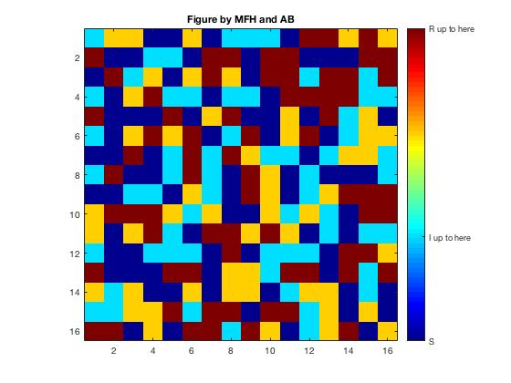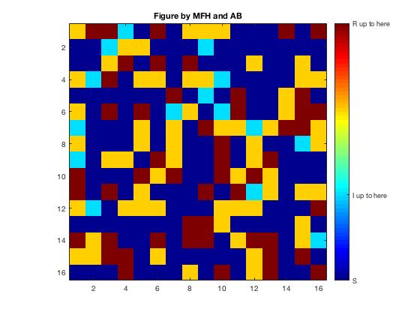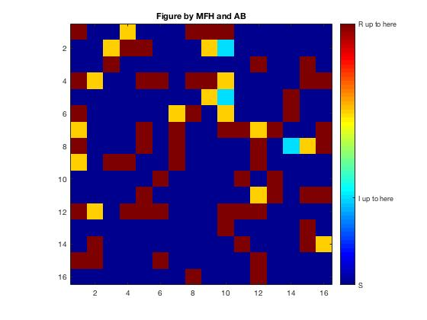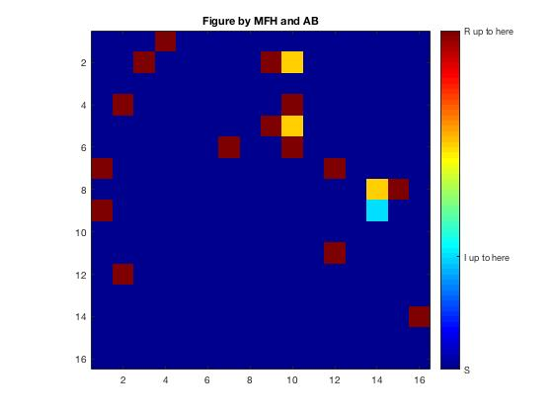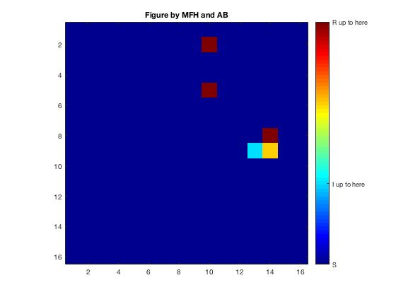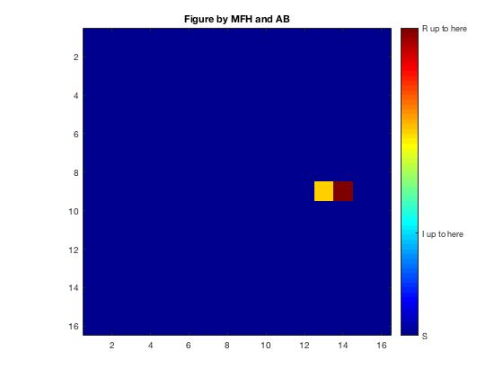

**6 - Stochastic model with synchronous updating and a probability of infection, “p”, of 0.2**

The following images show that a random map (p=0.2, a=1, g=2,I=0.05, immigration_rate=0 and synchronous). This model iteration (different from the previous from) includes immigration. Every time step, 5% of the cells in this model become Infected as individual immigrate into the population. The infection starts to decrease in later stages of the model, possibly due to the low probability of infection or the short durations of infection. However, it will never die completely as immigration regularly introduces infected individuals leading to a more stable (albeit artificially) infection.

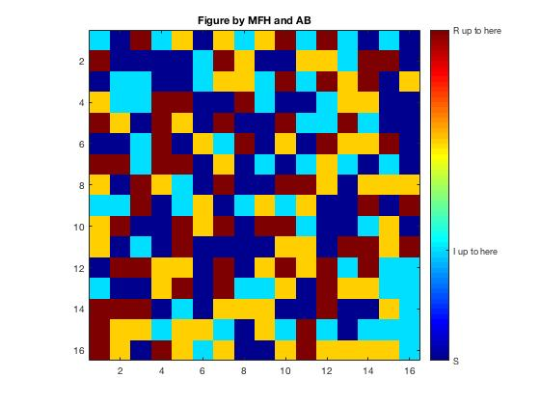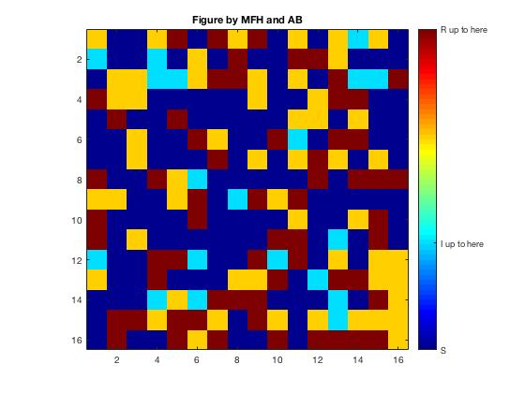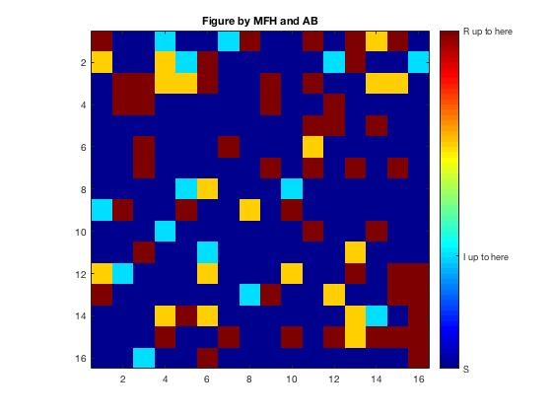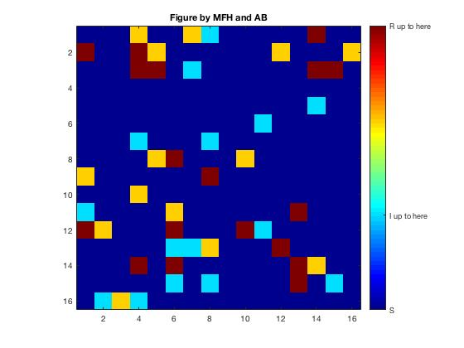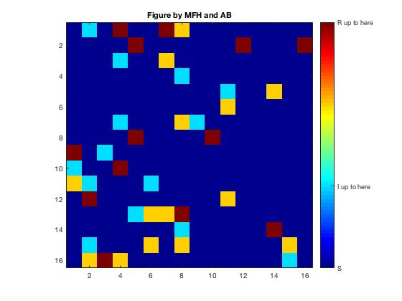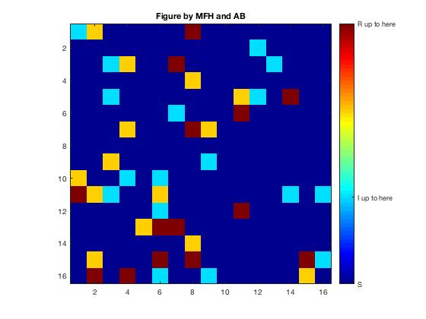

**7 – Stochastic model with synchronous updating, immigration_rate = 0.05 and a p= 0.2**

The following images show that we can get the entire system to work by altering all parameters. The parameter values in this model tended towards a more stable equilibrium (p=0.2, a=4, g=6, I=0.05 and synchronous). This particular model is meant to represent a latent infection with low virulence that stays in a dynamic population with immigration. The longer infection time, a allows for infected individuals to remain at that state for a longer period of time. In addition, g=6 allows for a longer period of immunity. This, combined with a lower probability of infection, as well as infected individuals entering the population through immigration, ensures a high probability of a latent outbreak that persists at low levels within the population. (With lower values of a and g, the infection tended to die out more rapidly).

